

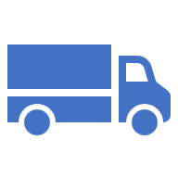



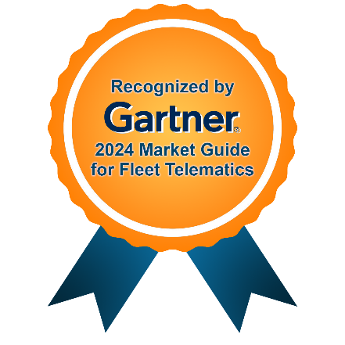

Technical Proposal Document
for
AM/NS-Hazira

Submitted on – December 31, 2025
Corporate HQ
Axestrack Software Solutions Pvt. Ltd.,
Office No.-19, 6th Floor, Jaipur Electronic Market, Near Riddhi Siddhi,
Gopalpura bypass, Jaipur – 302018, Rajasthan, India
Table of Contents
1. Respondent Information 1
1.1 Axestrack Overview 1
1.2 Axestrack Expertise & Recognitions 2
1.2.1 Going beyond real-time visibility (unified platform for logistics) 2
1.2.2 Recognized by analysts 4
1.2.3 Stability with scale 5
2 Proposed Solution 6
2.1 Our Understanding of AM/NS Business Process 6
2.1.1 Problem Statement 6
2.1.2 Key Challenges 6
2.2 To-be Process 7
2.2.1 Smart Traffic Regulation at Plant Tri-Junctions & Choke Points 8
2.2.2 Dynamic Zone Access & Vehicle Throttling 8
2.2.3 AI-Based Reversal Safety at Loading Bays 8
2.2.4 Unauthorized Parking & Lane Obstruction Detection 9
2.2.5 End-to-End Traffic Visibility & Control Dashboard 9
2.2.6 Vehicle Traceability & Predictive Analytics 9
2.3 Hardware at each stage: 10
2.4 Technical Scope 11
2.5 Out of Scope 11
3 Assumptions 11
4 Pragmatic View of Product Roadmap & Innovations Planned 12

Respondent Information

Axestrack Overview
Since its inception in 2008, Axestrack has been at the forefront of transforming the logistics and transportation industry through innovative digital solutions. What began as a small-scale operation in Jaipur has evolved into a leading player in India's logistics landscape.
Our growth story is a testament to the power of entrepreneurship. A team of like-minded individuals united to create a company that would redefine the way logistics is done. Today, Axestrack is proud to serve over 250,000+ commercial vehicles across 100+ cities, offering a comprehensive range of digital solutions. (For more about the platform please visit - https://www.axestrack.com/)
Our flagship product, the Axestrack Operating System (commonly known as aOS), leverages cutting-edge AI technology to optimize supply chain operations. By providing real-time data, analytics, and insights, we empower businesses to make informed decisions, improve efficiency, and reduce cost.
Beyond telematics, we offer a comprehensive suite of digital solutions tailored to meet the unique needs of our clients. From seamless integration with ERP systems to advanced analytics and AI-driven insights, we empower businesses to build a robust digital thread that drives efficiency and growth. By digitizing information and processes, we help our clients stay ahead of the curve and achieve their long-term goals.
At Axestrack, we believe in partnering with our clients to achieve their strategic objectives. By understanding their unique needs, we tailor our solutions to deliver maximum value. Our commitment to innovation, quality, and customer satisfaction has made us a trusted partner for businesses across India.
Further, we have accomplished ourselves as true partners to some of the marquee clients in the industry. Key mentions are: -
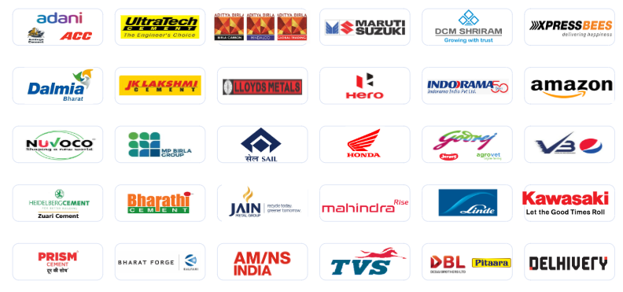

Axestrack Expertise & Recognitions

Going beyond real-time visibility (unified platform for logistics)
Axestrack with its suite of products (xSwift, Connected Plant Logistics, Managed Control Tower, Connected Port Logistics, etc.) provides state-of-the-art tracking and visibility to shippers and fleet owners.
The unified, single-pane view across all platforms facilitates rapid and informed decision-making. This connected operating system is structured into three key layers: See, Understand & Learn, and Act.

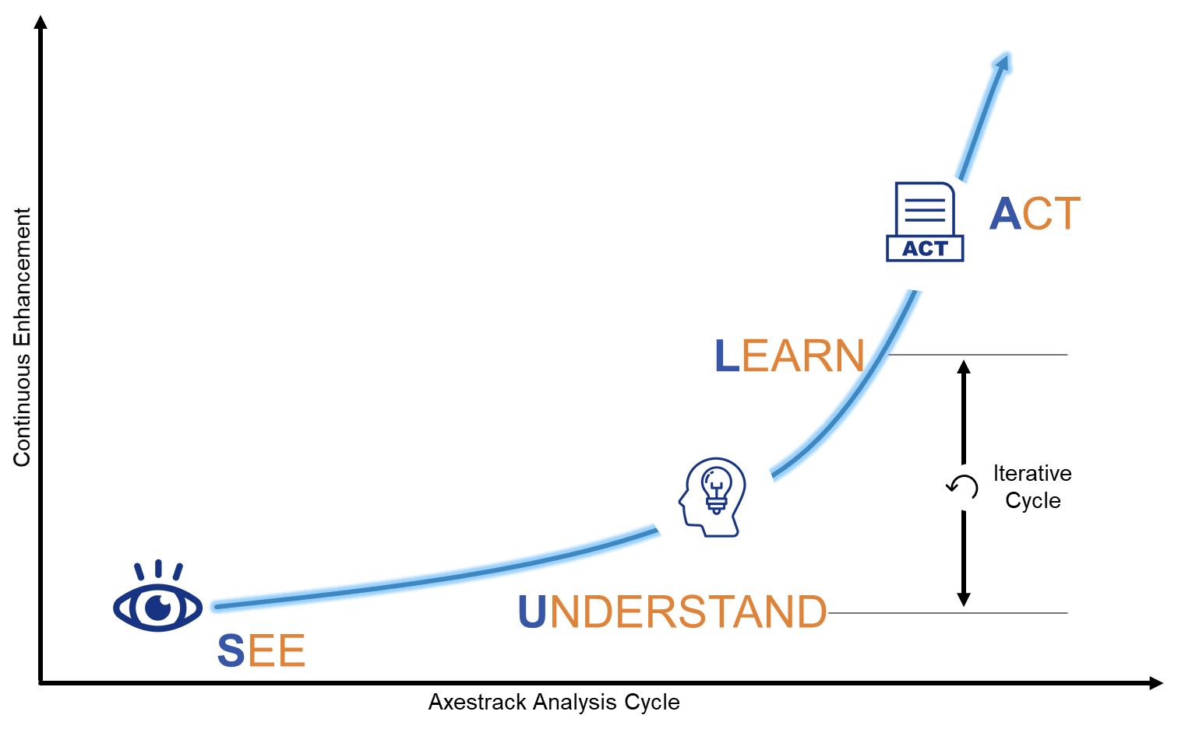
- The See layer aggregates data from multiple sources, including third-party GPS/Telematics systems, 3PL providers, ERP/TMS platforms, toll systems, government portals, OEM systems, third-party SIMs, and open APIs. This data is consolidated into a comprehensive data pool via a robust integration layer.
- The Understand & Learn layer leverages advanced AI and machine learning capabilities to transform this data lake into a data pool, enabling deeper insights and meaningful analytics.
- The Act layer presents this processed data through unified platforms, offering actionable analytics and reports. These insights empower the Managed Control Tower to make real-time interventions, ensuring efficient operations and improved outcomes.

Recognized by analysts
Axestrack has been widely recognized as a top digital solution provider through industry research, awards, and strategic partnerships. Axestrack has received numerous awards and accolades for its innovative digital solutions, including Gartner’s 2024 Market Guide for Fleet Telematics.
Axestrack believes in excellence which led our innovations and product capabilities recognized by multiple analysts and market leaders to solve transportation challenges in the industry.
According to Gartner ‘The fleet telematics market is growing, driven by the increasing demand for efficient fleet management solutions and operational optimization. This growth is catalyzed by widespread telematics adoption, supportive regulatory frameworks, reduced operational costs and enhanced customer satisfaction through real-time visibility on deliveries, driver safety and retention. The integration of AI, ML, and big data analytics is poised to propel the market forward by delivering advanced insights and predictive capabilities for fleet management.’

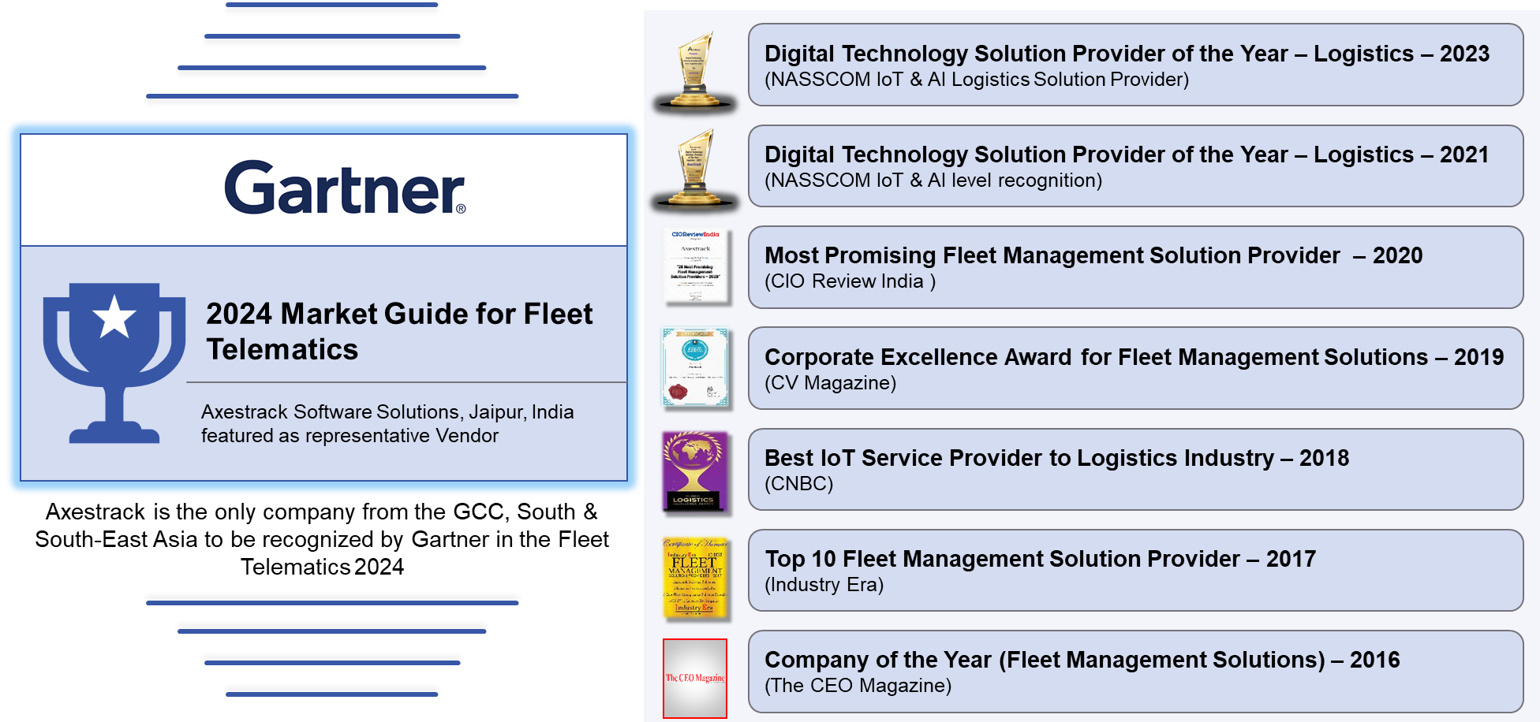

Stability with scale
At Axestrack, we are more than a solution provider—we are strategic partner. With over 15 years of experience in logistics and technology, and the management of our own fleet of 200+ vehicles, we leverage our deep industry expertise to proactively analyze key business KPIs and recommend targeted solutions that address operational gaps. As a bootstrapped and profitable organization, we currently manage 2.5 lakh+ fleets and oversee lakhs of trips monthly.
Our in-house Center of Excellence (CoE) designs, develops, and deploys cutting-edge digital solutions tailored to the logistics industry. These solutions support every stage from proof of concept (POC) to full implementation and enhancement. Our unified platform (Connected Plant Logistics) seamlessly integrates with any ERP system as a bolt-on solution, enabling faster, more efficient plant operations and driving impactful improvements across internal plant logistics processes.

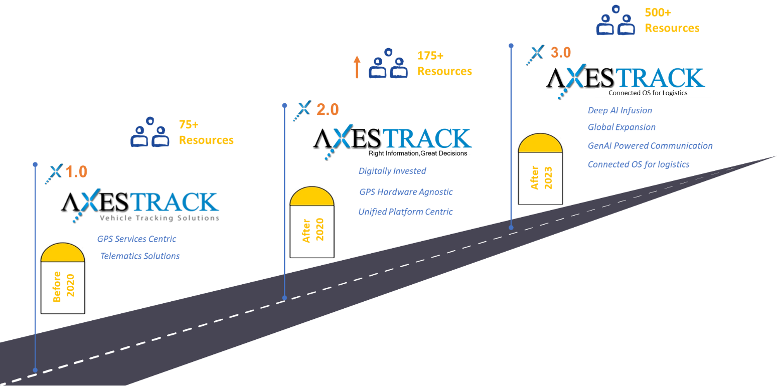

Proposed Solution

Our Understanding of AM/NS Business Process

Problem Statement
AMNS operates an integrated steel plant at Hazira, Surat, which is currently undergoing a major capacity expansion aimed at nearly doubling its production capacity. Earlier, all finished goods dispatches were centrally managed through a common marshalling yard, enabling controlled vehicle movement and centralized traffic coordination. As part of the expansion initiative, the central marshalling yard has been dismantled, and dispatch operations have been decentralized. Individual production units such as CRM-1, CRM-2, HRM, and other departments now manage dispatches independently through dedicated warehouses located adjacent to their manufacturing facilities.
This decentralization has resulted in a substantial increase in internal vehicular traffic without any corresponding enhancement in road infrastructure. The impact is most pronounced in the CRM-1 zone, which experiences severe congestion during peak hours—particularly in the evening during shift changes when employee movement overlaps with commercial vehicle traffic. In addition to increased traffic volume, CRM-1 also faces challenges related to poor vehicle discipline at loading points. Incoming trucks often park in unauthorized areas, including active traffic lanes, further aggravating congestion and creating safety risks. Moreover, vehicles are frequently required to reverse into loading bays, increasing the likelihood of accidents due to blind spots and limited maneuvering space. In the recent past, multiple near-miss incidents have been reported in this area, highlighting the urgent need for improved traffic control, parking discipline, and safer loading practices within the plant.

Key Challenges
- Uncontrolled increase in internal vehicular traffic due to decentralized dispatch operations without corresponding road infrastructure upgrades
- Severe congestion in critical zones (especially CRM-1) during peak hours caused by the overlap of employee movement and commercial vehicle dispatches
- Unauthorized parking of trucks near loading areas, including on active traffic lanes, leading to traffic bottlenecks and safety risks
- Unsafe vehicle maneuvering practices, particularly reversing into loading bays, increasing blind-spot and collision hazards
- Rising safety exposure, evidenced by multiple near-miss incidents involving vehicles and personnel in recent months
- Lack of centralized traffic monitoring and enforcement, resulting in poor vehicle discipline and inconsistent adherence to safety protocols

To-be Process
To address the growing internal traffic congestion and safety risks at the AMNS Hazira plant, Axestrack has conducted a detailed on-ground assessment by visiting the facility and engaging with key stakeholders across operations and logistics. Based on this assessment, Axestrack proposes the deployment of its Connected Plant Logistics (CPL) platform, a comprehensive, AI-powered solution designed to optimize internal traffic flow, enhance safety, and bring centralized visibility across decentralized dispatch operations.
The CPL platform leverages a smart grid of hardware devices, intelligent traffic logic, and advanced analytics to regulate vehicle movement inside the plant in real time. By dynamically managing traffic at critical junctions, loading bays, and high-risk zones such as CRM-1, the platform ensures smoother vehicle flow, enforces discipline, minimizes unsafe maneuvers, and significantly reduces safety hazards. The solution not only addresses current operational challenges but also creates a data-driven foundation for continuous improvement in plant logistics and traffic planning.
Illustrative Image:
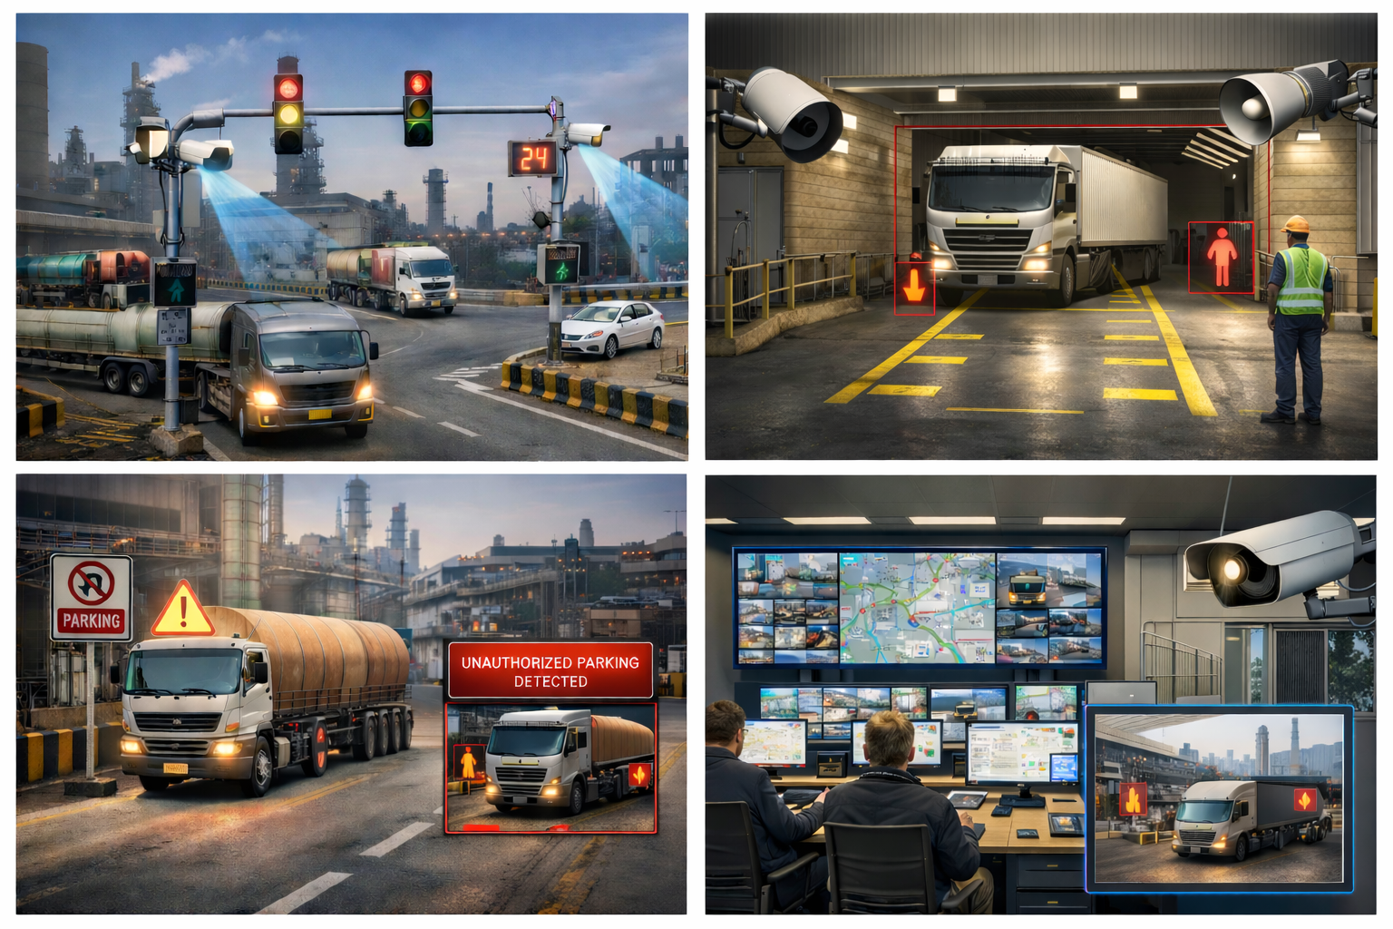

Smart Traffic Regulation at Plant Tri-Junctions & Choke Points
CPL deploys intelligent traffic management units at critical tri-junctions and intersections inside the steel plant, especially near CRM-1 and dispatch corridors. Each junction is equipped with smart cameras, traffic controllers, and AI-based decision logic that continuously monitors vehicle movement across all incoming and outgoing lanes.
The system dynamically regulates traffic by prioritizing lanes based on real-time conditions such as peak shift hours, congestion levels, vehicle type (commercial vs employee transport), and vehicle reversal at loading bay. Unlike fixed traffic signals, CPL adapts signal timing and lane permissions automatically based on live data.
Advantages
- Smoothens traffic flow during peak shift change hours
- Prevents congestion spillover across plant.
- Reduces manual traffic intervention by security personnel
- Improves overall throughput without modifying road infrastructure

Dynamic Zone Access & Vehicle Throttling
CPL enforces controlled entry into sensitive or high-traffic zones such as CRM-1 by dynamically limiting the number of vehicles allowed at any given time. Cameras and access logic track how many vehicles are already present and automatically permit or restrict new entries via traffic regulations based on predefined safety and capacity thresholds.
This ensures that traffic inside constrained areas remain within manageable limits and prevents sudden surges caused by uncoordinated vehicular movement.
Advantages
- Eliminates overloading of narrow or high-risk internal roads
- Maintains safe vehicle density in CRM-1 and similar zones
- Reduces gridlocks caused by simultaneous vehicle arrivals
- Brings discipline and predictability to vehicular movements

AI-Based Reversal Safety at Loading Bays
At loading bays, CPL deploys smart cameras with AI-based human and vehicle detection, integrated with PA systems. When a vehicle enters reverse mode for loading, the system continuously scans blind spots and the surrounding area for any manpower movement or obstruction.
If a safety risk is detected, the system immediately provides audio alerts to the driver and notifies nearby personnel, guiding the driver to stop or adjust movement until the area is clear.

Advantages
- Significantly reduces blind-spot related accidents and near-misses
- Protects shop-floor personnel during reversing operations
- Provides real-time guidance instead of post-incident reporting

Unauthorized Parking & Lane Obstruction Detection
CPL continuously monitors internal plant lanes using smart cameras installed at fixed intervals. The AI engine identifies vehicles parked in unauthorized areas, or active traffic lanes and instantly flags these violations.
Real-time alerts are pushed to the safety and operations teams, enabling immediate corrective action before congestion or safety incidents escalate.
Advantages
- Prevents blockage of main traffic corridors
- Improves vehicle discipline near loading and waiting areas
- Enables faster response by safety and security teams
- Reduces secondary congestion caused by illegal parking

End-to-End Traffic Visibility & Control Dashboard
All traffic data from junctions, loading bays, and plant roads is consolidated into a centralized CPL dashboard. Safety and logistics teams get real-time visibility into vehicle movement, congestion hotspots, violations, and abnormal patterns.
This allows proactive traffic control instead of reactive incident handling.
Advantages
- Single source of truth for plant traffic operations
- Faster incident detection and resolution
- Improved coordination between logistics, safety, and operations teams
- Enables informed decision-making during peak or emergency situations

Vehicle Traceability & Predictive Analytics
CPL records detailed movement data such as vehicle entry/exit time, dwell time at particular stretch, route taken, and congestion patterns. This historical data is analysed to identify recurring bottlenecks, unsafe zones, and peak traffic trends.
Over time, this enables AMNS to fine-tune dispatch schedules, traffic rules, and infrastructure planning.
Advantages
- Data-driven optimization of dispatch and traffic planning
- Continuous improvement of safety inside the plant
- Supports future capacity expansion planning
- Moves traffic management from reactive to predictive

Hardware at each stage:
Sr No | Stage | Hardware | Quantity per Check Point | Checkpoints | Hardware Count
1 | CRM Trijunction 1 | Traffic Light | 9 | 1 | 9
 |  | RFID Reader | 2 | 1 | 2
 |  | ANPR Camera | 4 | 1 | 4
 |  | AT Controller | 4 | 1 | 4
2 | CRM Trijunction 2 | RFID Reader | 2 | 1 | 2
 |  | ANPR Camera | 2 | 1 | 2
 |  | Traffic Light | 1 | 1 | 1
 |  | AT Controller | 2 | 1 | 2
3 | CRM Trijunction 3 | Traffic Light | 11 | 1 | 11
 |  | RFID Reader | 4 | 1 | 4
 |  | ANPR Camera | 6 | 1 | 6
 |  | AT Controller | 6 | 1 | 6
4 | CRM Trijunction 4 | Traffic Light | 2 | 1 | 2
 |  | RFID Reader | 1 | 1 | 1
 |  | ANPR Camera | 1 | 1 | 1
 |  | AT Controller | 1 | 1 | 1
5 | CRM Road | ANPR Camera | 15 | 1 | 15
 |  | Traffic Light | 15 | 1 | 15
 |  | AT Controller | 15 | 1 | 15
 |  | PA System | 15 | 1 | 15
6 | Loading Bays | Smart Camera | 2 | 9 | 18
 |  | PA System | 1 | 9 | 9
 |  | AT Controller | 1 | 9 | 9
Total |  |  |  |  | 154

Technical Scope
- Deployment and configuration of smart devices and sensors
- Building a network of interconnected hardware systems
- Digital twin creation to enable operational visibility

Out of Scope
- ERP and any other third-party integration
- On-premise set up.

Assumptions
- AMNS will provide the timely approvals and sign-off for the work products (Digital Layer) delivered as part of project.
- We assume all vehicles to be equipped with fast tag/RFID cards for vehicle counting and traffic regulation.
- The above commercials do not include the Civil and IT infrastructure. AMNS has to provide the same.
- Any new requirements beyond the scope of this proposal will be considered as change request for which separate effort & cost to be estimated.
- Issues and bugs related to 3rd Party product or services or plugins will be out of scope for this project.
- All project deliverables will be in English.
- The Network, security, IT and other infrastructure for this project to be owned by AMNS team. Axestrack’s responsibility is only to provide recommendation related to these areas.
- It will be SaaS deployment solution. On-Premise network configuration will be out of scope.
- Any hardware requirement will be charged separately.
- AMNS team will be providing instruction and sign-off after each testing stage (i.e SIT & UAT).
- Train the trainer approach will be followed for the user training
- AMNS need to provide all the required approvals and passes to the Axestrack Onsite team (if required during project implementation) at Plant.

Pragmatic View of Product Roadmap & Innovations Planned
Axestrack’s product roadmap has been built keeping current and future needs of the industry in scope. The roadmap establishes our commitment to the innovations and capabilities which we co-develop with client to ensure these developments are relevant to the needs of the clients.
The intent behind this vision is simple. We understand that “connectivity” is the way for future and hence the core of any solution must embrace the connected part and should support the mechanisms which promotes connectivity.
We understand that while vision is clear, we also need to keep the structural elements flexible and modular. Hence, the design of our architecture and roadmap has been envisioned to be ‘modular and agile’.
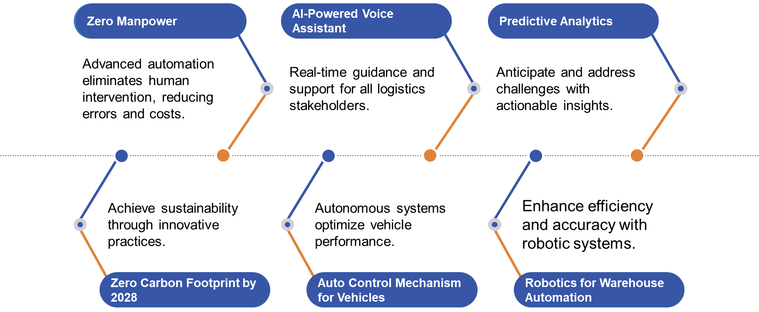


www.axestrack.com
www.

